Supplementary material

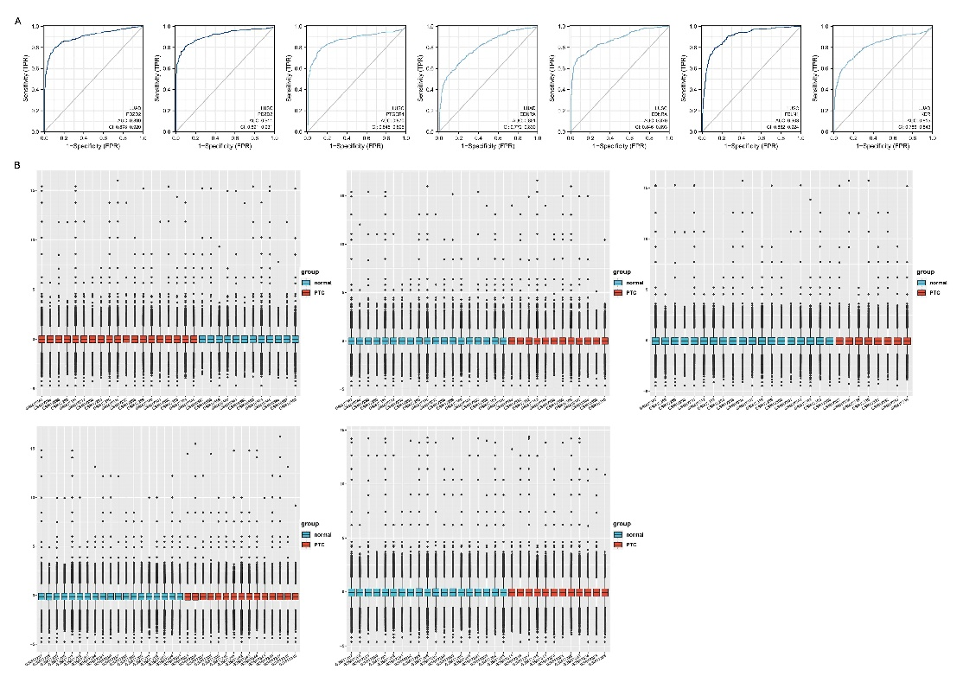
Supplementary Fig. 1. Kaplan-Meier plot analysis [7] was performed to assess the relationship between the expression of key genes and survival in LUSC. p ≥ 0.05.

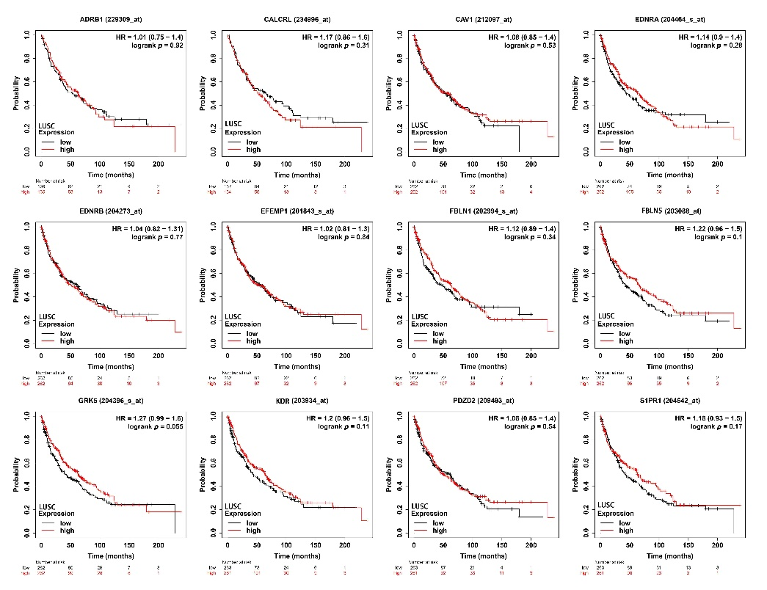
Supplementary Fig. 2. (A&B) ROC curve analysis [2] was performed to assess DEGs in lung cancer diagnosis.

